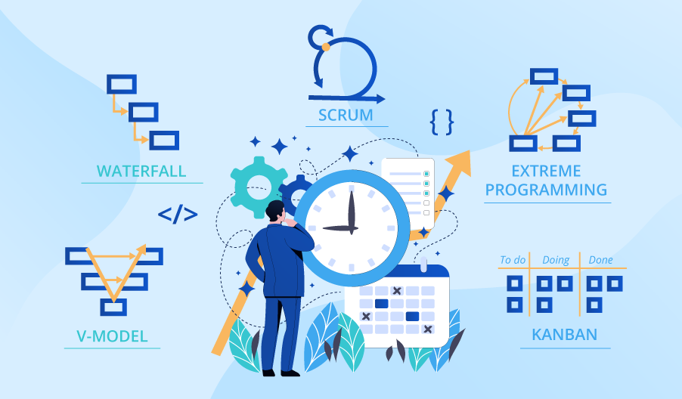

**SE423**

**Software Project Management**

**Activity**

**Activity 1. Classic Mistakes**

Read the "Classic Mistakes" case study. Identify classic software development mistakes as defined by McConnell. Groups are to be created to find classic mistakes from each of the four dimensions (people, process, product and technology):

1. Each group will produce a brief summary that includes no more than 2-3 key mistakes from each of the project dimensions and any other interesting observations on the case study.
2. Write a recommendation based on your analysis on how your group would have ran the project had you been in charge; be sure to address the common mistakes identified above.
3. Describe any tradeoffs (for quality and cost) that would need to be made in support of your recommendations.
4. Submit one document including your identified 2-3 key mistakes sets and analysis to LMS.

Be sure to include all group member's names in your submission.